**DAILY ONLINE ACTIVITIES SUMMARY**

|  |  |  |  |  |  |  |  |  |
| --- | --- | --- | --- | --- | --- | --- | --- | --- |
| **Date:** | **13-6-2020** | | | | | **Name:** | **Likhitha.M** | |
| **Sem & Sec** | **6th sem ‘A’** | | | | | **USN:** | **4al17cs046** | |
| **Online Test Summary** | | | | | | | | |
| **Subject** | | **Python Application programming** | | | | | | |
| **Max. Marks** | | **30** | | **Score** | | | **29** | |
| **Certification Course Summary** | | | | | | | | |
| **Course** | **Front end Development- HTML** | | | | | | | |
| **Certificate Provider** | | | **Great learning** | | **Duration** | | | **3 days** |
| **Coding Challenges** | | | | | | | | |
| **Problem Statement:**  1.Write a C Program to calculate Electricity Bill  2. How to find the first non repeated character of a given String?  3. Write a Java Program to determine whether a given matrix is a sparse matrix  4.Python Program to print the pattern  Description: Input: Number of rows is 5  Output Pattern is: A B C D E F G H I J K L M N O | | | | | | | | |
| **Status: completed** | | | | | | | | |
| **Uploaded the report in Github** | | | | | **yes** | | | |
| **If yes Repository name** | | | | | **https://github.com/likhithaMantaral/Daily-status** | | | |
| **Uploaded the report in slack** | | | | | **yes** | | | |

**Online Test Details:**

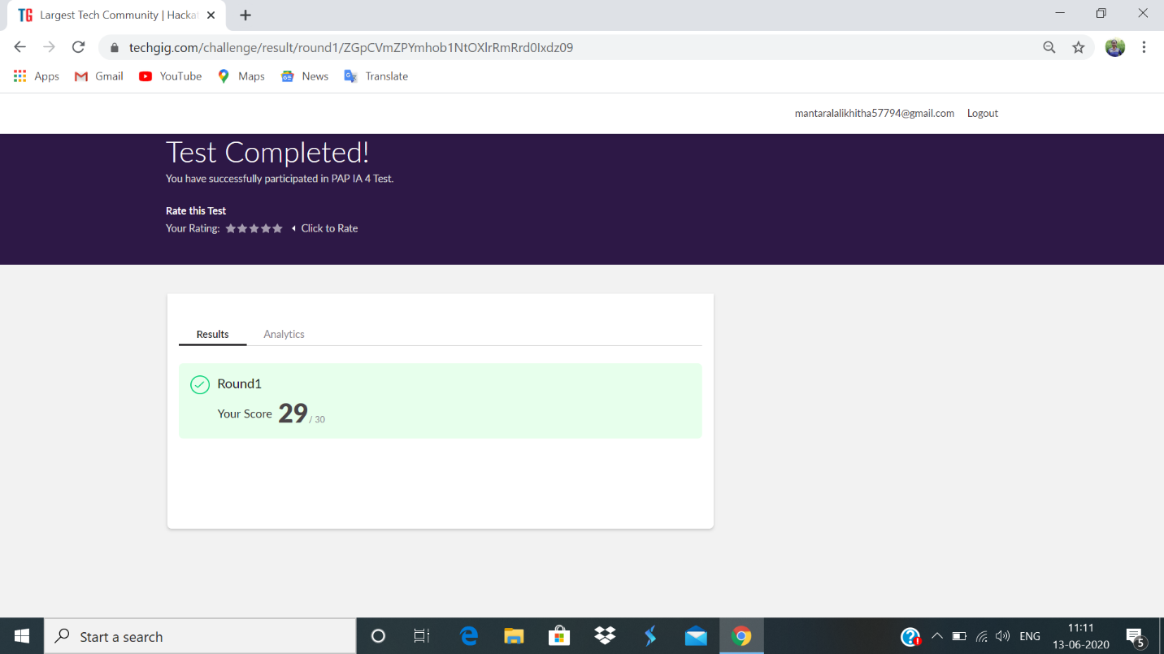

Certification Course Details:

**HTML structure:**

Create an HTML page. ALL of HTML are defined using tags. Tags come in pairs-it has a opening tag and a closing tag.

**Paragraph tags:** creating paragraph.

**More on Tags:** Some other tags in head.

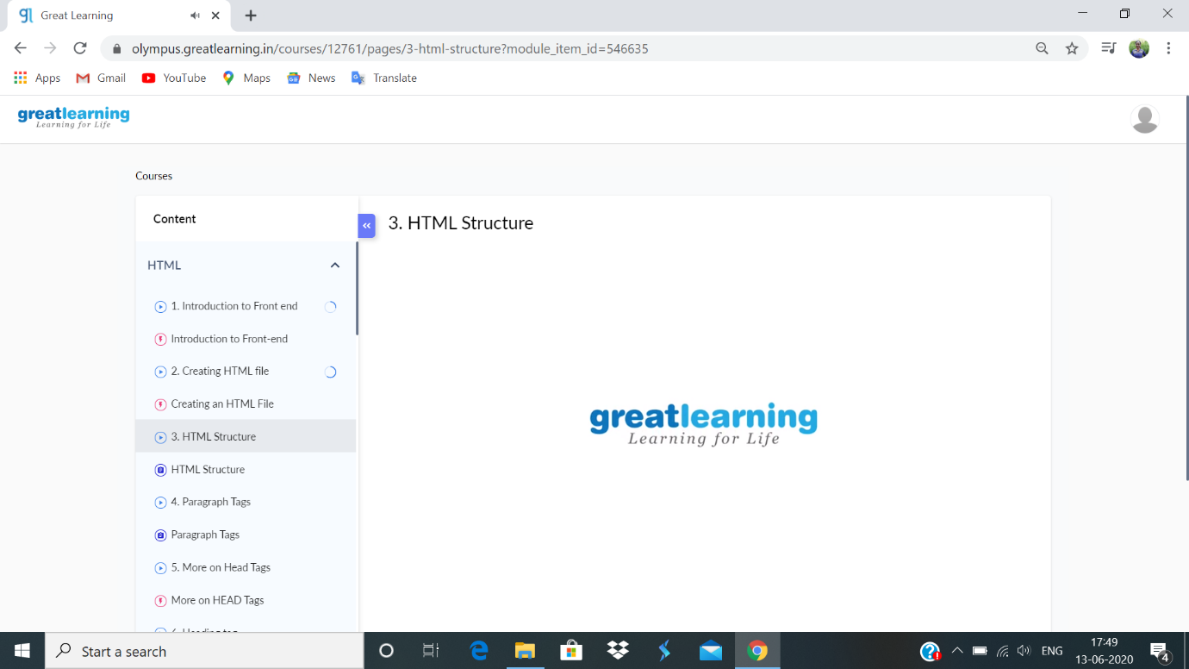

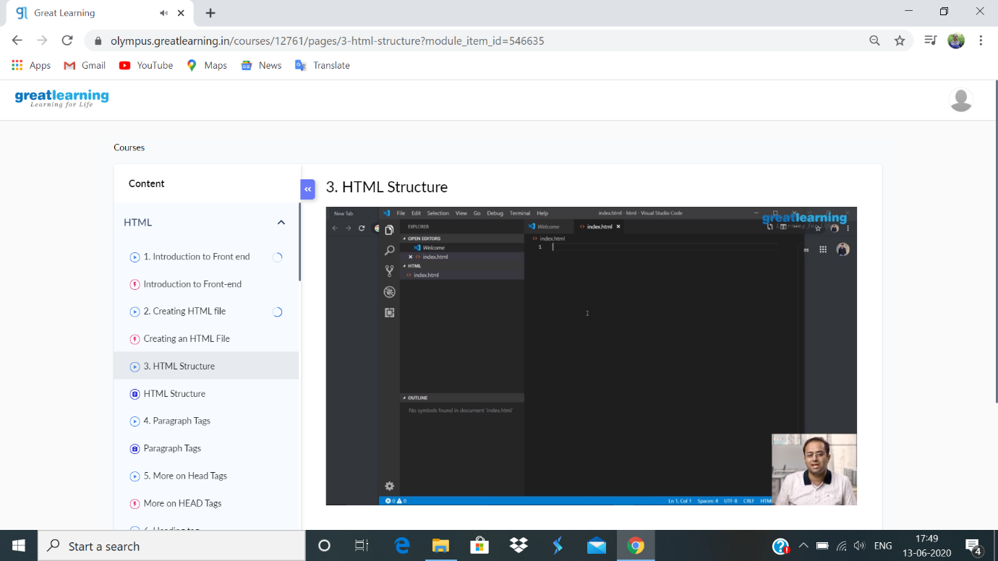

**Coding challenge:**

**1.**

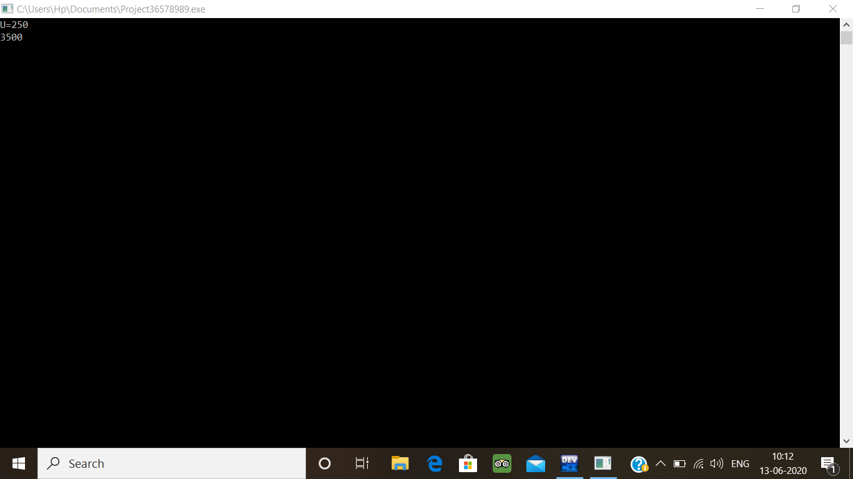

2.

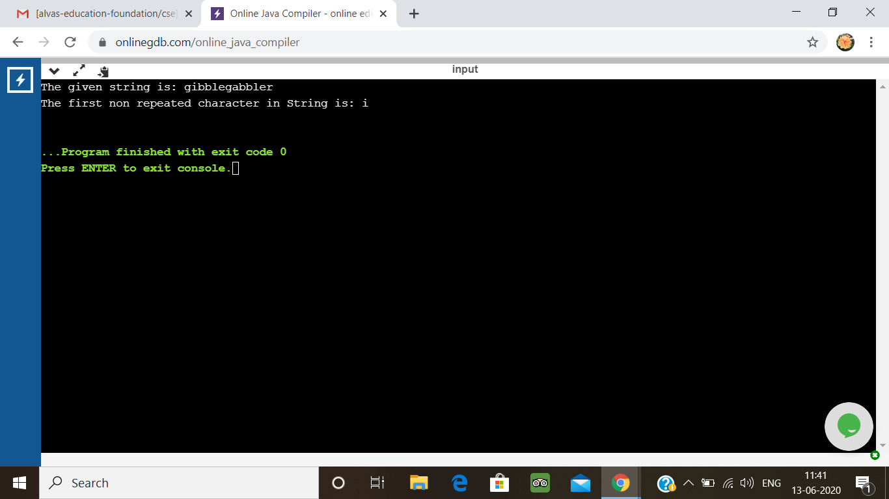

3.

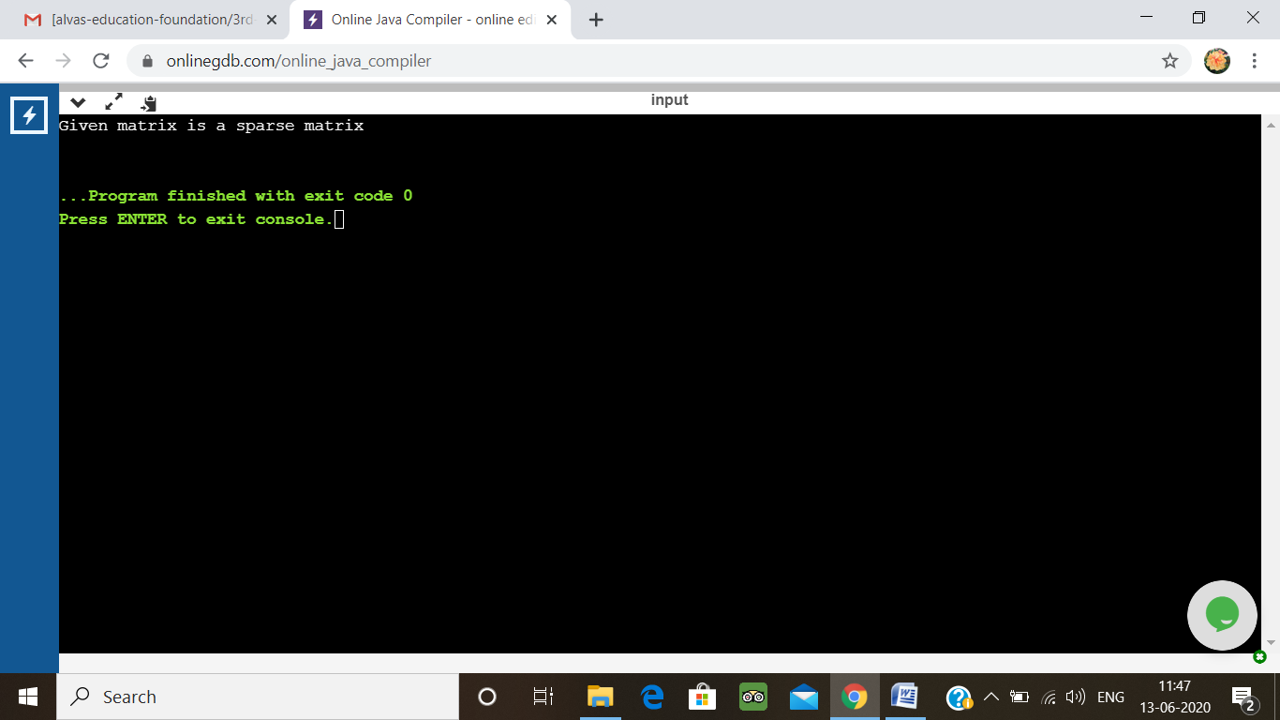

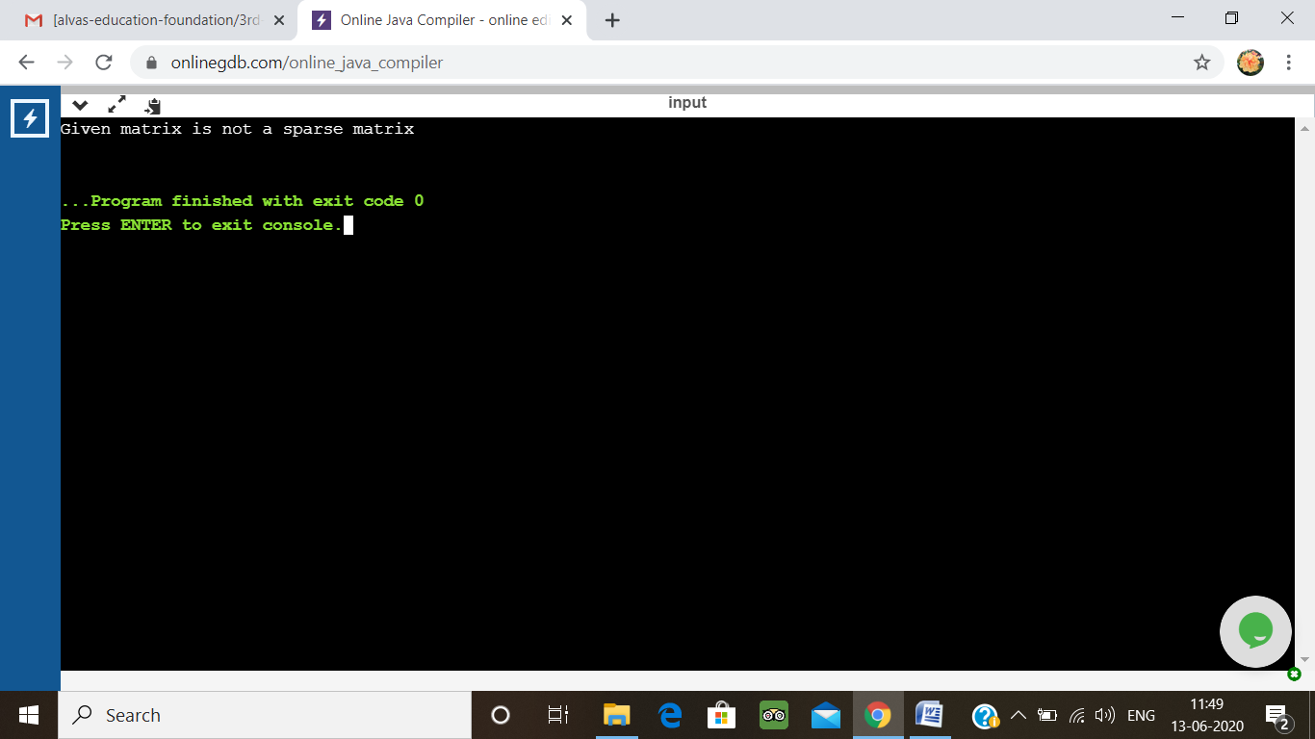

4.

